

Good Morning everyone, I'm Matteo Campana and today I will present my thesis work denominated "Semantic Segmentation for Remote Sensing Images"

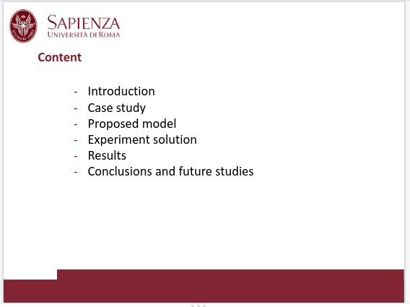

This is the summary of my presentation. I will start with a brief introduction where I will present the scenario in which this study was carried out, and then move to analyze the starting proposed model and the experimental solutions in their various components, ending with the discussion of the results and possible future developments.
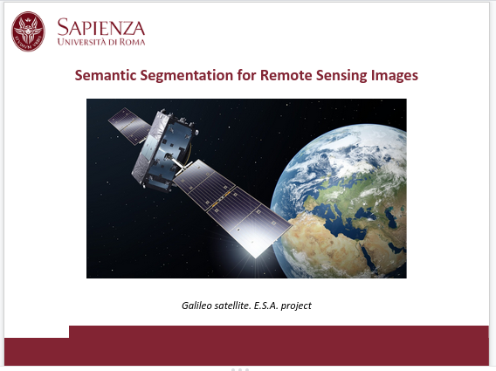

The detection of objects in images from high-resolution remote sensing consists in determining, automatically or semi-automatically, if an image aerial or satellite contains one or more entities of interest and, subsequently, in determining their position within the area under investigation. However, extracting consistent information in urban environments, characterized by an enormous density of objects classified in a confined space or within the same area, remains a particularly demanding challenge.

Recently, promising results towards this goal were obtained making use of deep convolutional neural networks models, instead of classic techniques such as template matching and pixel classification algorithms.

Herein, starting from the image-2-image translation model, based on deep convolutional neural networks we developed an improved method that makes use of self-distillation with no labels pre-training technique to extract high accuracy semantic segmentation masks.

In the classic image classification task, the problem can be formulated as follows: “given a query, obtain the labels of all objects present”.

In the field of current data analysis, digital images are treated as three-dimensional matrices of significant dimension. These huge matrices can contain a sub-vector within each cell that can identify the properties of the pixel, such as the color ranges or other information.

The set of properties, relation to images, is defined in the literature as “channels” of the image. However the properties of the individual pixels may not be limited only to the chromatic “channels” they may also contain additional metadata relating the nomenclature of the individual pixels such as the object to which the pixel belongs.

This specific additional metadata related to each pixel that tells us which object the pixel belongs to is denominated in literature as the mask of the pixel.

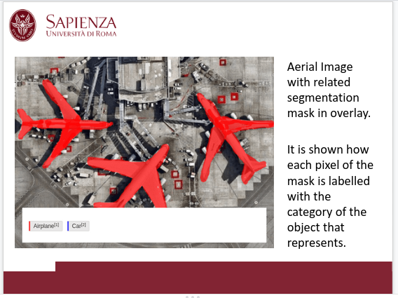

For example, given the photo of an airplane, it is possible to add a channel to the image to tell whether the pixel is part of the "plane" object, or it belongs to those that make up the background.

To do this, various techniques and methods have been developed over the years. Currently, the most commonly used one is semantic segmentation, or image segmentation, which consists in grouping parts of an image that belong to the same class of objects. It is a form of pixel-level “prediction”, as each pixel in an image is classified according to a category.

Image segmentation is a more advanced and challenging process than ordinary image classification. It brings the work to a higher level by trying to accurately identify the exact boundary of the objects in the scene.

Turning back to our example we intend to create an algorithm/model for images deriving from remote sensing applications, with the “semantic segmentation” techniques, capable of identifying whether each pixel belongs to the airplane or the background. In practice the task assigns each pixel of the studied area a specific identification category previously defined in an arbitrary manner.

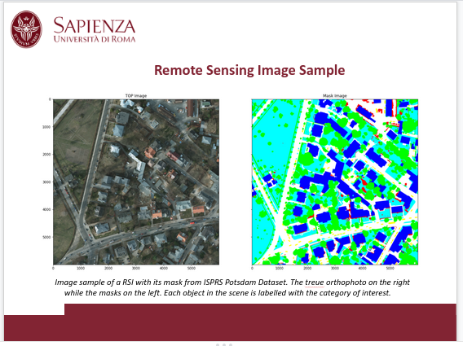

Over the past 20 years, several studies and reports have demonstrated the usefulness and effectiveness of this methodology in various applications or contexts, such as monitoring urban areas, land use, environmental protection, and traffic control.

The classification phase generally focuses on extracting specific categories from the image, such as building, linear structures, vehicles, and artificial and natural vegetated surfaces such as agricultural crops, woods, meadows, swamps.

However, extracting consistent information in urban environments, characterized by an enormous density of objects classified as in a confined space or within the same area of interest, remains a particularly demanding challenge.

The two main critical factors that usually affect the process of achieving the basic goals were, on one side, a high level of variability within the same class combined with a low variability between classes and , on the other side, local weather conditions at the time of image shooting.

With regard to the first point, it is possible to observe that, for the sample to be classified, the data relating to its characteristics, as they are, in our case, size, shape, or color, may vary to a considerable extent between objects belonging to the same class, while samples of different classes differ a lot in these areas.

Buildings identified by the same class are often built in different materials such as concrete, bricks, glass, and have different structures.

Different shapes and colors characterize the vehicles.

Depending on the seasonand the state of the vegetation can vary in density, extension, and color. On the other hand, semantically different objects classified manually may have similar characteristics (such as roofs, sidewalks, roads made of the same material like concrete).

As far as the weather conditions are concerned, the problem relates to the possibility that these can affect visibility by occluding parts of the image. Cloudy weather or a large amount of air pollution, mainly present in urban or industrial areas, cause distortion and artifacts in the reference images, which will then recur, causing problems in various algorithm implementations, leading to errors of various kinds.

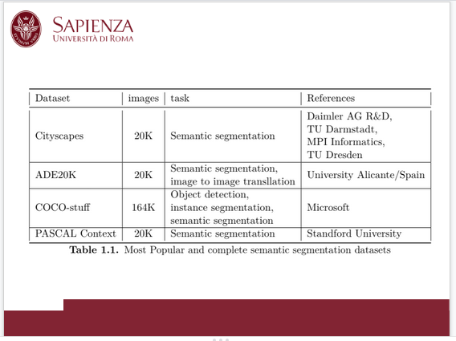

Semantic segmentation, however, while remaining a challenging task compared to other areas of application of computer vision, has made great strides thanks to numerous efforts and significant investments.

It is indeed possible to easily find extensive archives of annotated image data. These datasets are currently in public use and freely available, and are also constantly updated and maintained by large companies and/or government agencies.

Each of the mentioned datasets focuses on a particular aspect of semantic understanding. Cityscapes focus on the semantic understanding of urban street scenes. ADE20K is focused on landscape scenes. The COCO-stuff (Common Objects in COntext) dataset instead focuses on object detection and image capturing. Finally PASCAL dataset Context focuses on classifying environments such as offices, apartment interior, and laboratories.

Unlike the above mentioned datasets, current efforts to achieve accurate aerial segmentation for the purpose listed above are hampered by the scarcity of organic data collections. This problem is likely due to the intrinsic complexity and high costs of the satellite imagery acquisition process in terms of time and money.

Unlike natural images, which can be quickly captured and classified, satellite images require a high budget for acquisition and adequate experience to extract the correct masks. In different contexts, moreover, specific competence is needed to identify the various objects of interest and assign them the proper classes.



The I.S.P.R.S. international company for photogrammetry and remote sensing provided the dataset on which the work of this thesis is based. It is a non-governmental organization dedicated to developing international cooperation for the advancement of photogrammetry and remote sensing and their applications.

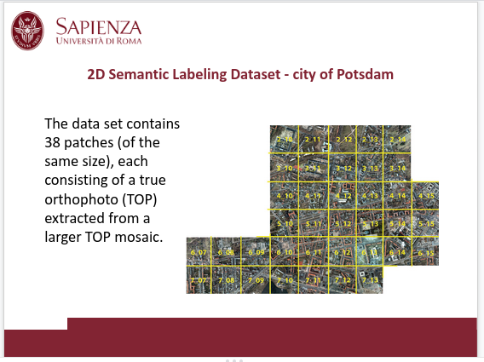

The dataset used refers to the city of Potsdam. It shows a typical historical city with large blocks of buildings, narrow streets, and dense settlement structures.

This dataset was originally designed as a benchmark for the automated extraction of urban objects from data acquired by airborne sensors. What makes this task challenging is the very heterogeneous appearance of objects like buildings, streets, trees and cars in very high-resolution.

The dataset was provided in the form of a tessellated map divided into macroblocks. Each of the 38 macroblocks of the map consists of high-resolution (6000x6000 pixel) treue orthophoto (TOP) images. Each area was associated with a semantic segmentation mask manually classified into six land cover classes.

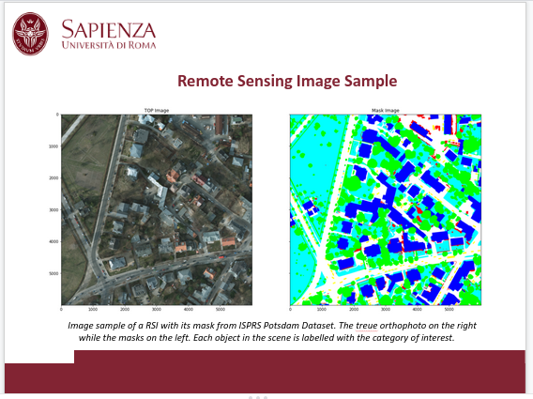

Since the first appearance of satellite images, a field that began to develop in the civil field from the 1980s, several increasingly sophisticated technologies have been used. Among the main techniques employed, we can mention clustering algorithms such as k-nn, k-means, or decision-making processes such as random-forest.

However, with the increase in the precision of instruments and sensors, which have made it possible to collect ever more detailed data, as well as larger images, these approaches have revealed their limitations, proving to be less and less adequate. Among the main problems that emerged, complexity and computational load were the most significant.

To obtain a high precision level of analysis it is not sufficient to analyze an image pixel by pixel but it is necessary to consider the context of each object. Models capable of understanding the individual instances to be identified and the context in which they are found have so far provided the most satisfactory results.

The analysis methodology, indicated by the acronym OBIA object-based image analysis, identifies two macro-areas of interest, the segmentation of images previously described and the classification of detected objects.

Of the two methodologies, semantic segmentation was the one that aroused the greatest interest in the last decade, not only in the field of Computer Vision but also in other disciplines such as biomedical technologies or the automation sector with particular interest in the automotive one.

The interest and progress of semantic segmentation technologies have promoted the rapid development of the Computer Vision sector, and thanks to the high adaptability of neural networks models, the progresses obtained in a given field were immediately applied to the other fields making possible an exponential development of the research. This process exploded in the computer vision community by 2014 with the use for the first time of convolutional neural networks. The study highlighted how the change of approach applied to the semantic segmentation competition and carried out using the PASCAL VOC dataset as reference, had led to an improvement in performance larger than twenty percent compared to previous techniques.

A further improvement and significant contribution came in 2015 from the field of biomedical sciences, within which a framework was developed for recognition and analysis of various biomedical data to help in the diagnosis of various diseases. Specific attention was paid in particular to deformations of the cranial cortex and the identification of malignant masses that can be easily escaped, due to their small size.

This framework took the name of UNet from the work of Ronnenberg et alia in which the encoder-decoder paradigm was introduced, and makes use of two convolutional networks. The first, with encoder functions, takes care of gradually reducing the representation space through convolutional filters. The second, with decoder function, takes the result of the first network as input and performs transpose convolutional operations intending to reconstruct the original image, or the segmentation mask given by the target, through various upsampling steps.

All the methodologies reported so far fall within the scope of techniques called supervised learning, through which, given the starting images and target image attempt to extract the segmentation mask for the samples not yet processed. In this process the larger the dataset the greater the accuracy that the model can reach. A limited quantity of reference samples can lead to poor performance in terms of model accuracy.

In recent years, various techniques and frameworks have emerged that allow us to train the networks without the need to resort to large amounts of reference images. These techniques do not use or make limited use of images already processed manually by experts in the field. This makes it possible to achieve excellent results even in the absence of large datasets mitigating the criticalities due to the reduced availability of already labeled material.

The goal of these new methods is to generate a reduced-size representation of the features of the image to be analyzed and then use that exact latent representation in a new network that aims to generate segmentation masks. Herein we illustrate a new methodology to extract segmentation masks from images obtained from satellite telemetry systems.

Based on the technique developed in the study “MARE: Self-supervised multi-attention resu-net” in combination with vector quantization, and the new self-distillation pre-training method DINO, in our work, we have tried to improve the model accuracy.

The work covered in this thesis based on MARE hinges on two major focal points. The first concerns a convolutional neural network that uses a ResNet as a backbone, combined with an architecture that follows UNet. The second lever, which is the peculiarity of the network used in the original paper MAResUNet by the authors Li et alia, consists in the insertion of a “Linear Attention Mechanism” between the skip connection.

The introduction of a “Linear Attention Mechanism” not only allows to effectively select the features, as demonstrated by the manifold works carried out on these mechanisms, but requires a lower computational cost than the most widespread attention algorithm based on “dot-product attention”.

Starting from the work on Masocci et al. the present study was directed at obtaining an improved version of the model, with special reference to the level of accuracy. In particular, the study aimed to improve the precision in rendering the predicted images with respect to the relevant target ones. To this end, various experiments were conducted. All the tested models share the same architecture, as described in the appropriate sections, and differ in their sizes, pre-training method, and the presence of quantization.

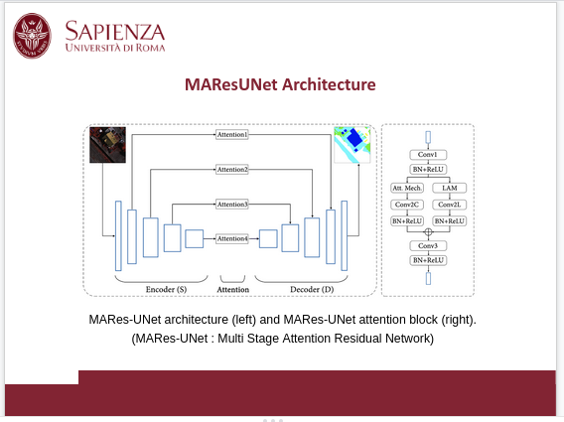

As the foundation for the design of the model presented in this thesis, we followed the same strategy of the article “MARE: self-supervised Multi Attention ResUnet for semantic segmentation in remote sensing”. The authors employ the network configuration conceived by Li et al. in their work “Multistage attention ResU-Net for semantic segmentation of fine-resolution remote sensing images”. The model uses the ResUNet framework, where skip-connections link the blocks between encoder and decoder and integrate custom-attention mechanisms layers called LAM ( Linear Attention Mechanism Module ).

These modules, which constitute an alternative to traditional Transformers, have been implemented to help the network to capture the relation information between the blocks. The LAM mechanism has been introduced in place of the classic attention mechanism to reduce the computational complexity due to the high cost of the dot product attention calculation and, consequently, the computation times.

Based on the LAM proposal, the authors redesign the skip connections of the original U-Net and design a ResU-Net with multistage attention layers (MAResUNet). The acronym MAResU-Net stands for Multistage Attention ResU-Net. It is the merge of ResNet, short for Residual Network, a specific type of convolutional neural networks that was introduced in 2015 by He et al. in their article “Deep Residual Learning for image Recognition”, and UNet which is a framework proposed by the document “U-Net: Convolutional Networks for Biomedical Image Segmentation” by Ronnenberg et al.

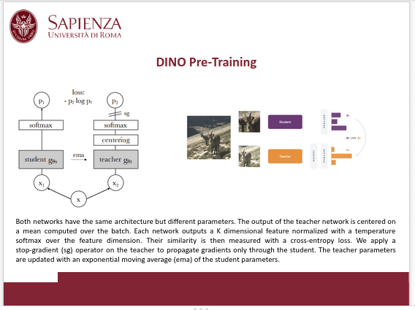

As previously described in the introduction, one of the main critical issues in the development of models for semantic segmentation in remote sensing is the lack of datasets and homogeneity in the nomenclature of the masks / labels.

To make up for this lack, various techniques have been refined over the years. These new techniques base their focus on extracting a latent representation of the various datasets independent of the target distributions (the masks in our study case).

These categories of approaches take the name of self-distillation training.

The strength of self-distillation learning lies in combining labeled and unlabeled samples to expand the pool of data available for model training. Consequently, it makes it possible to improve the model’s performance by reducing the load and data required for training by not resorting to huge data sets already labeled and cataloged.

This technique arises from the necessity of processing huge amounts of data not yet labeled, and that labeling manually would be costly in terms of time and human resources. Taking as an example the data treated in our thesis, those relating to satellite images, imagine how long and how many people are needed to extract the segmentation masks for an entire city.

So this method allows us to pre-train a network with a large amount of unlabeled data, to obtain an encoder capable of capturing a significant latent representation. Once this encoder has been obtained, we can use it to train a new network even with a small set of labeled data, avoiding overfitting phenomena from occurring.

Now that we have clarified the objectives of this methodology we can proceed to explain how it works.

Self-distillation is a learning paradigm where we train a student network to match the output of a given teacher network. Given an input image x, we fed different augmented versions to the two networks. Both networks output probability distributions over K dimensions. Given a fixed teacher network , we learn to match these distributions of the student compared with the teacher by minimizing the loss w.r.t. the network’s output of the two distributions.

Reaching this stage, we have to update the teacher network. To fulfill this, we cannot merely back-propagate the loss via the teacher, or we will train two different networks, in the same way, ending with a clone of the student. To avoid this scenario, we freeze the parameters of the teacher, and instead of back-propagating the error through it, we update the teacher through a momentum-encoder using an exponential moving average based on the student parameters.

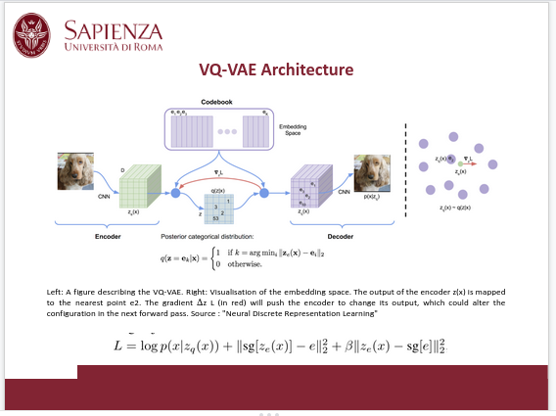

We now continue our discussion with the second version of the tested models.

In this version, use was made of the framework proposed in the article "Neural Discrete Representation Learning", which combined with our already defined architecture has led to a model based on the VQ-VAE concept using attention mechanisms. The vector quantization technique was introduced due to its considerable success which focuses on image super-resolution and image style transfer.

In our case of study we employ the codebook studied in the article of Oord et alia. The model designed by the authors and named VQ-VAE extends the standard variational autoencoder model adding a discrete codebook component to the network.

This codebook is a list of vectors associated with a corresponding index used to quantize the network bottleneck. It works by comparing the encoded input against all vectors inside the codebook, and the relative codebook vectors closest in Euclidean distance are fed to the decoder.

We define a latent embedding space e of dimension K times D, where K is the size of the discrete latent space , and D is the dimensionality of each latent embedding vector ei.

The model takes an input x, that is passed through an encoder producing as output ze(x). The discrete latent variables z are then calculated by a nearest neighbor look-up codebook. The input to the decoder is the corresponding embedding vector ek. One can see this forward computation pipeline as a regular autoencoder with a particular non-linearity that maps the latents to 1-of-K embedding vectors.

The posterior categorical distribution q(z|x) probabilities are defined as one-hot encoded vector as shown in the slides (posterior = q(z=ek | x) )

Where ze(x) zeta encoded is the output of the encoder network. We view this model as a variational autoencoder in which we can bound log p(x) with the ELBO. Our proposal distribution q(z = k|x) is deterministic, and by defining a simple uniform prior over z we obtain a Kullback-Leibler divergence constant and equal to log K.

During forward computation the nearest embedding zq (x) is passed to the decoder, and during the backwards pass the gradient ∇z L is passed unaltered to the encoder. Since the output representation of the encoder and the input to the decoder share the same D dimensional space, the gradients contain useful information for how the encoder has to change its output to lower the reconstruction loss.

The last equation specifies the overall loss function. It has three components that are used to train different parts of VQ-VAE. The first term is the reconstruction loss which optimizes the decoder and the encoder. Due to the straight-through gradient estimation of mapping from ze(x) to zq (x), the embeddings ei receive no gradients from the reconstruction loss log p(z|zq (x)). Therefore, in order to learn the embedding space, we use one dictionary learning algorithm, Vector Quantisation (VQ). The VQ objective uses the l2 error to move the embedding vectors ei towards the encoder outputs ze(x) as shown in the second term of the loss equation.

Finally, since the volume of the embedding space is dimensionless, it can grow arbitrarily if the embeddings do not train as fast as the encoder parameters. To make sure the encoder commits to an embedding and its output does not grow, we add a commitment loss, the third term in the loss equation.

The decoder optimizes the first loss term only, the encoder optimizes the first and the last loss terms, and the embeddings are optimized by the middle loss term. Since we assume a uniform prior for z, the KL term that usually appears in the ELBO is constant w.r.t. the encoder parameters and can thus be ignored for training.

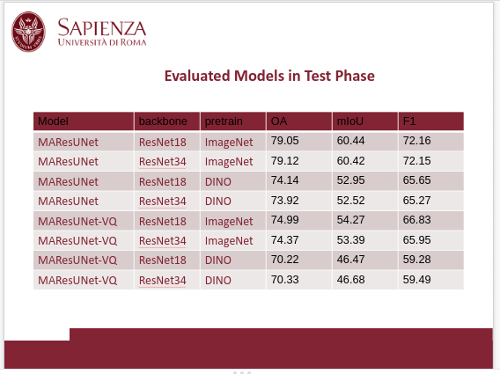

Now that we have finished describing the various models proposed, we can go and analyze the results obtained from the experiments performed.

First of all, the relative performance of the models can be discussed based on tables which report relative scores. It can be readily noticed how the models that do not use vector quantization or pre-training techniques through self distillation based on the DINO method stand out. From these results, it can also be deduced that among the models that use ResNet18 and ResNet34 as the backbone, the one that manages to obtain better scores is the model with fewer parameters.

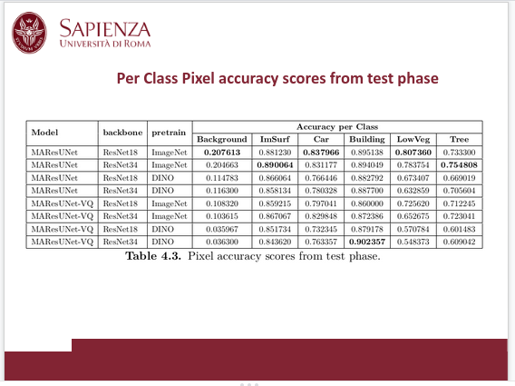

To go into further detail, we can address the data in tables, which report the various scores on the metrics of pixel accuracy for the individual segmentation classes of interest. For each model, the class that introduces the greatest amount of noise is the class related to the background. This class, which represents and helps classify areas such as swimming pools, sports fields, and car parks, has the most heterogeneity and introduces the most significant number of false positives in the inference phase.

It introduces numerous classification errors, considerably lowers the average accuracy and global mIoU value of the individual models. It is also evident from the extracted samples shown below in figures that only the models pretrained with ImageNet and which do not use Vector Quantization can detect this class (represented by the red color). These assumptions are supported by the tests. In the presence of vector quantization or pre-training based on DINO, the various scores drop drastically, reaching around ten percent in precision in both methods.

Passing to the analysis of the remaining segmentation classes, we can mention how "Buildings" stands out among all, which manages to obtain the best metrics.

The class of "Car" distances itself a little while always maintaining an excellent representation in the inference phase.

With regard to the classes that represent "Tree" and "LowVeg" (low vegetation), it was not surprising to find that the results were worse due to the difficulty of the model in establishing the contours of the segmentation masks deriving from these latter classes of interest. In fact, unlike cars and buildings, the vegetation does not have well-defined edges; moreover, it is widely heterogeneous both in colors and in expansion. It is often easy to confuse trees with low vegetation due to shadows generated by the passage of cloudy masses, mists, or shadows cast by tall buildings.

It should also be considered that noise introduces the background class, which turns out to be the one in greatest contact with the latter two.

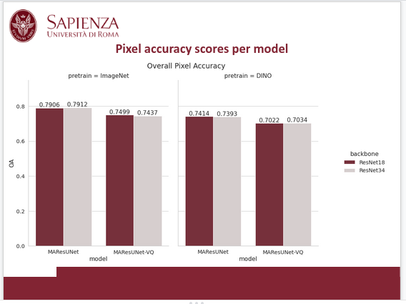

As a final, but not less important, remark the self-distillation learning techniques proved to be ineffective compared with the transfer learning methodology, which lays its foundations on pre-training with ImageNet. We can hypothesize that the ImageNet pre-training has obtained better results due to the difference in the size of the datasets. While our training set from which the encoders were trained based on the DINO methodology had a number of about 11, 000 entries, ImageNet can boast a number of entries in the millions. If added to the overfitting phenomenon to which our models are subject, with an emphasis on tests that make use of the pre-training technology we use, this assumption translates into a small number of samples on which to base the training of our networks. Therefore, it is assumed that with a larger dataset, the results may improve until they reach and surpass those set by the best model available among those tested.

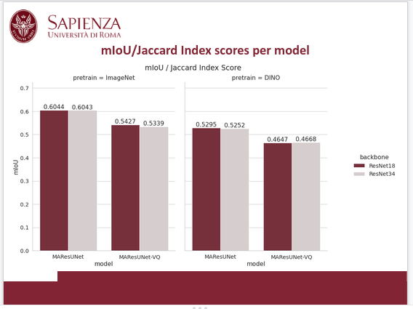

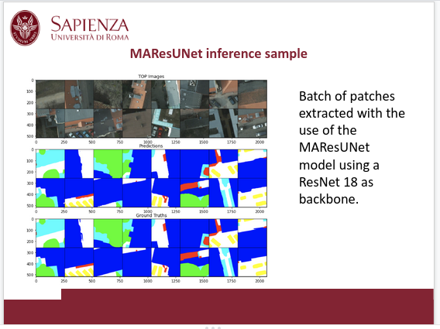
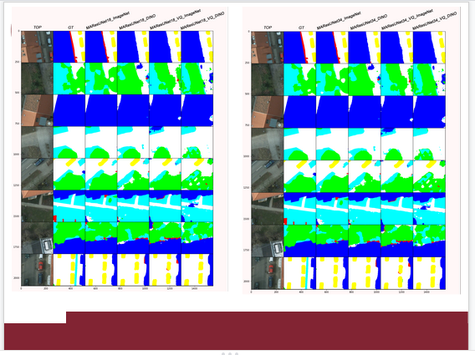

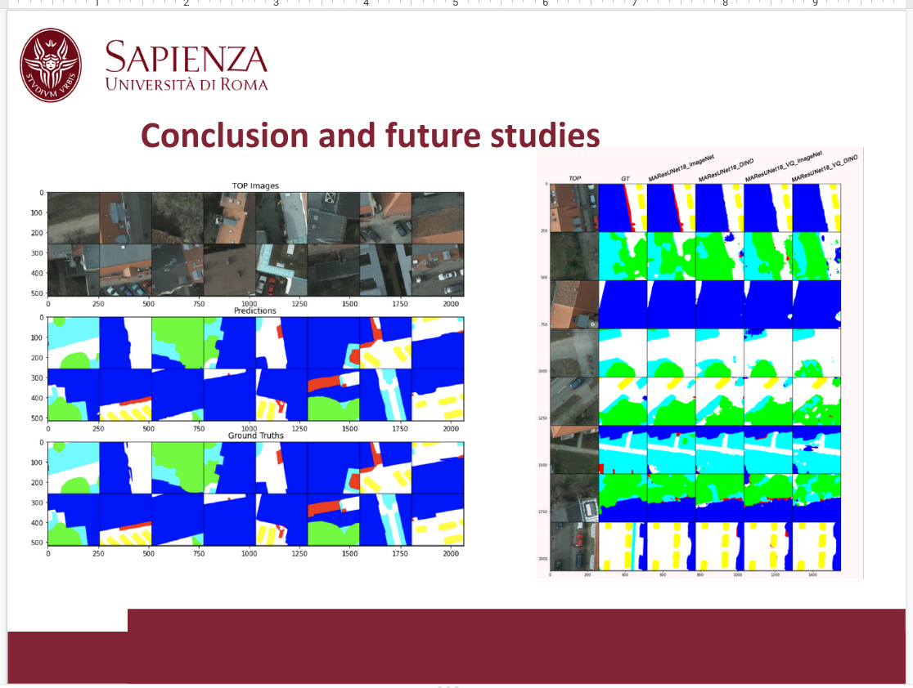

Starting from the work on Masocci et al. by previous authors, the present study was directed at obtaining an improved version of the model, with special reference to the level of accuracy. In particular, the study aimed to improve the precision in rendering the predicted images with respect to the relevant target ones in semantic segmentation.

All the tested models share the same architecture, and differ in their sizes, pre-training method, and the presence of quantization.

The models employed as encoders, used as the backbone for the framework treated in this thesis, are ResNet18 and ResNet34. As highlighted in the previous discussion section, those models which relied on less parameters, i.e., those that used a ResNet18 as the backbone, turned out to be the best.

In many cases, models with more parameters achieve higher scores at the expense of a higher computational cost, present both in the training and inference phases. This allows us to define good models that do not require excessive effort on the part of the machines to function. Powerful machines require a large amount of energy to operate while using models with fewer parameters, and it is possible to save in terms of energy, an issue that should not be overlooked, especially in our case where we are going to analyze images that can be processed in real-time by drones or satellites.

As far as future developments are concerned, one attractive possibility would be to devise new models capable of operating on machines with a lower energy demand.

Studies in the semantic classification of remote sensing images are increasingly improving. New models are emerging over the years, increasing the accuracy of sensors and instruments in the industry.

Nowadays, transformers seem to be the basis of the "revolution" currently underway and the key to gaining access to increasingly sophisticated, precise, and efficient models.

Furthermore, new approaches are currently being developed to reduce the computational load deriving from the calculation of the attention mechanism. Another most promising field for ongoing and future consideration is that relating to training techniques. The teacher-student paradigm, previously addressed in this thesis, is gaining credibility as a necessary standard to compete with the best models currently available in the literature.

With some due precautions, it may be possible to adapt these new methodologies to allow for their inclusion and utilization into the specific framework used in this thesis.

